1.

SELECT *

FROM Patient

WHERE DOB < TO_DATE('01-JAN-1990', 'DD-MON-YYYY');

Output:

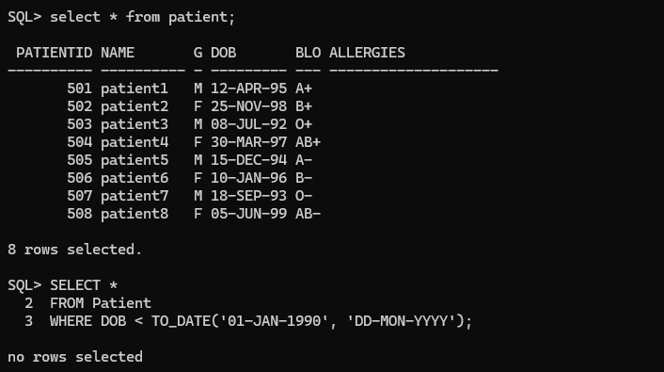

2.

select *

from doctor

where departmentid = 101 or departmentid = 102;

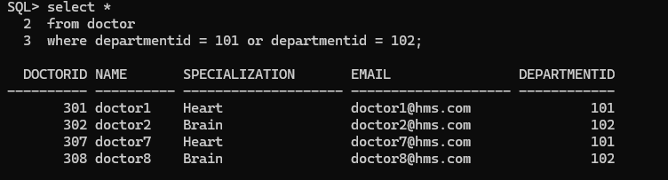

3.

SELECT * FROM treatment

WHERE cost > 50000;

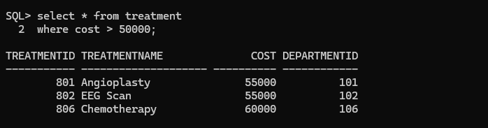

4.

SELECT *

FROM Patient

WHERE BloodGroup <> 'O+';

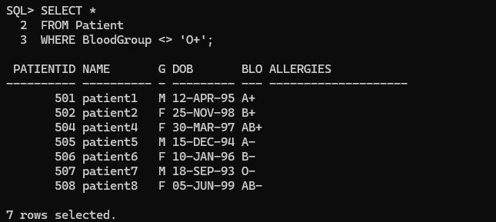

5.

SELECT *

FROM treatment

WHERE Treatmentname LIKE ‘%surgery%’;

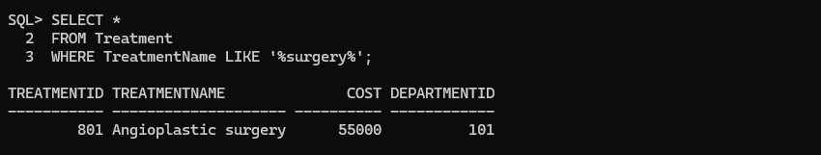

6.

SELECT *

FROM department

WHERE deptname LIKE ‘Cardio%’;

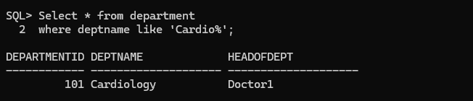

7.

SELECT *

FROM doctor

WHERE name LIKE ‘%n’;

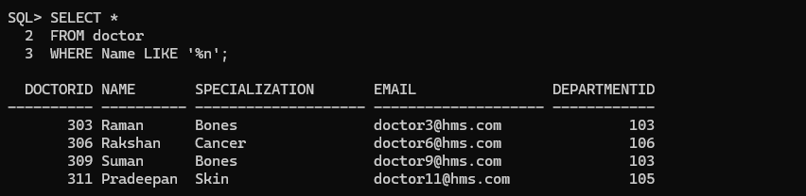

8.

SELECT *

FROM patient

WHERE LENGTH(name) = 6;

